ATTACHMENT a
Stranding Study Area Photographs
Table of Contents
Page
Potential Stranding/Trapping Areas Surveyed at Gray Eagle Bar - American Bar. 11
AB-A 11
AB-B1 11
AB-B2 11
Potential Stranding/Trapping Areas Surveyed at Gray Eagle Bar - American Bar. 12
AB-C 12
AB-D1 12
AB-D2 12
AB-E 12
Potential Stranding/Trapping Areas Surveyed at Fords Bar. 13
FB-A1 13
FB-A2 13
FB-B 13
FB-C 13
Potential Stranding/Trapping Areas Surveyed at Fords Bar. 14
FB-D1 14
FB-D2 14
FB-E 14
FB-F 14
Potential Stranding/Trapping Areas Surveyed at Fords Bar. 15
FB-G 15
FB-H 15
FB-I 15
FB-J 15
Potential Stranding/Trapping Areas Surveyed at Fords Bar. 16
FB-K 16
FB-L 16
FB-M 16
FB-N 16
Potential Stranding/Trapping Areas Surveyed at Fords Bar. 17
FB-O 17
FB-P 17
FB-Q 17
FB-R 17

Potential Stranding/Trapping Areas Surveyed at Gray Eagle Bar – American Bar.

AB-A | AB-B1
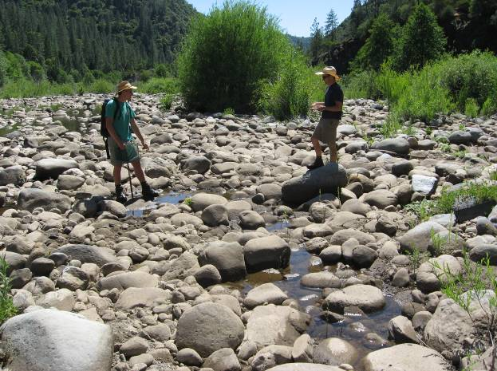 | 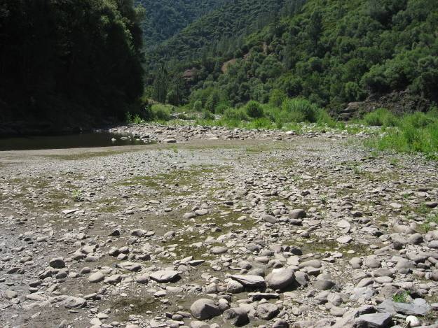

AB-B2
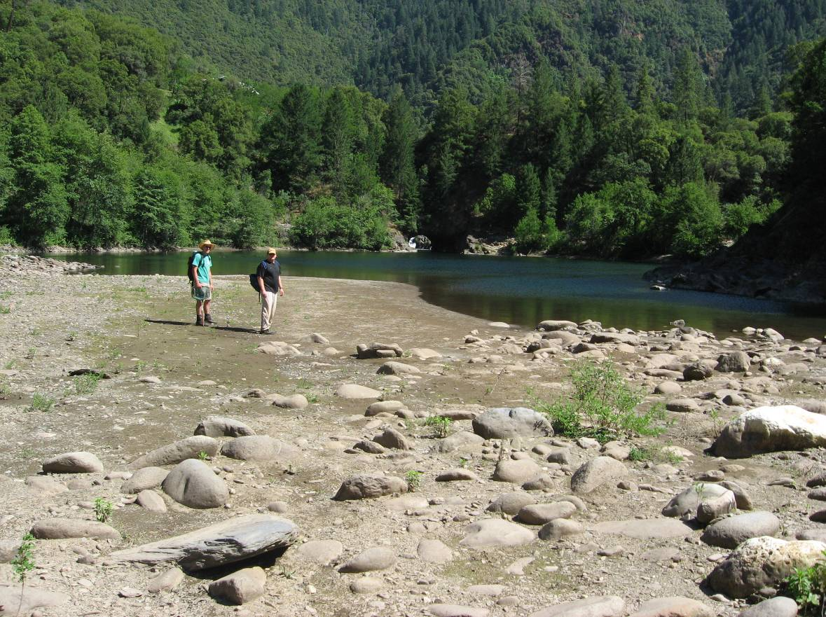

Potential Stranding/Trapping Areas Surveyed at Gray Eagle Bar – American Bar.

AB-C | AB-D1
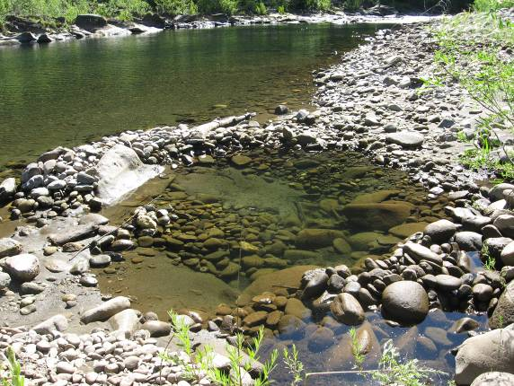 | 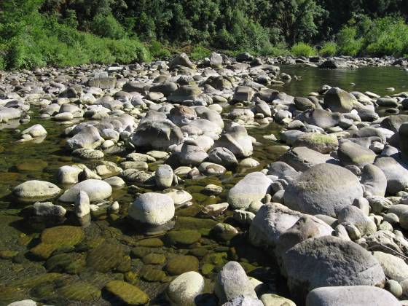
AB-D2 | AB-E
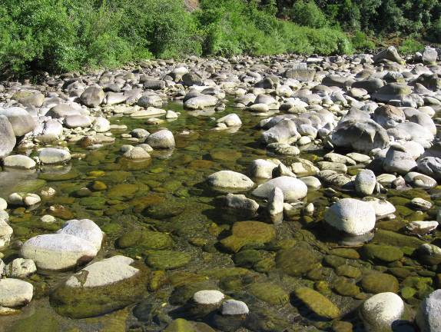 | 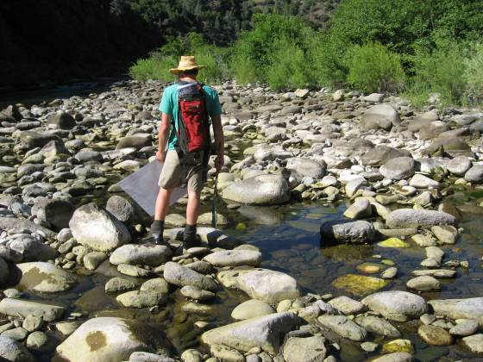

Potential Stranding/Trapping Areas Surveyed at Fords Bar.

FB-A1 | FB-A2
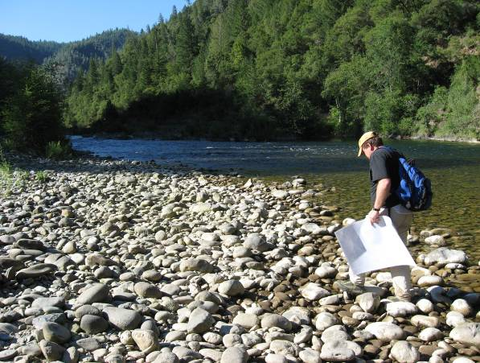 | 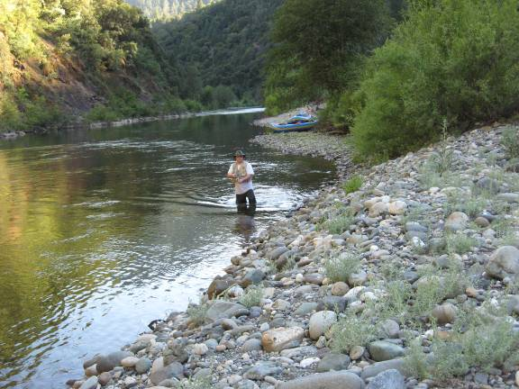
FB-B | FB-C
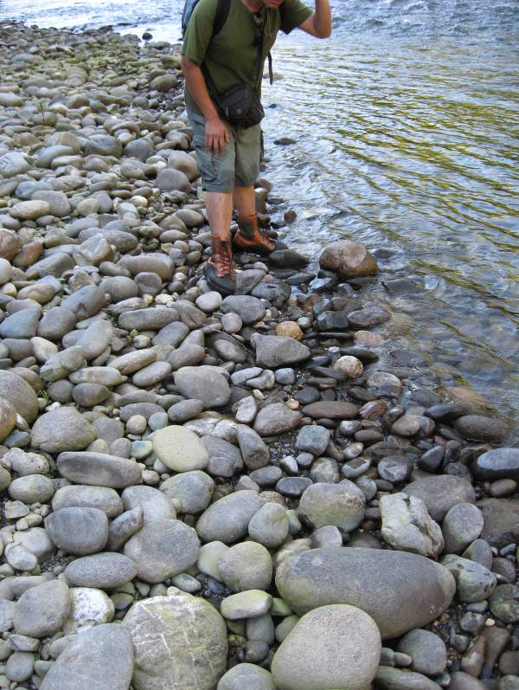 | 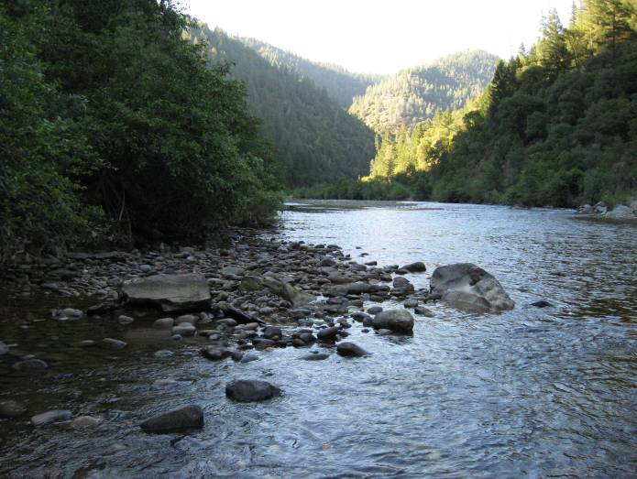

Potential Stranding/Trapping Areas Surveyed at Fords Bar.

FB-D1 | FB-D2
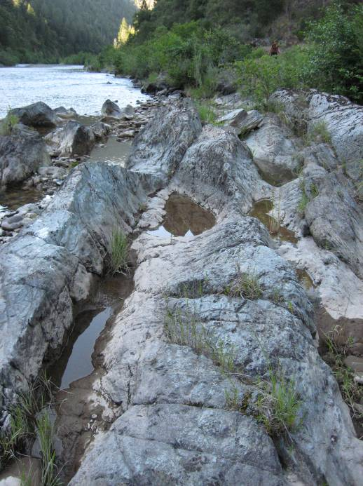 | 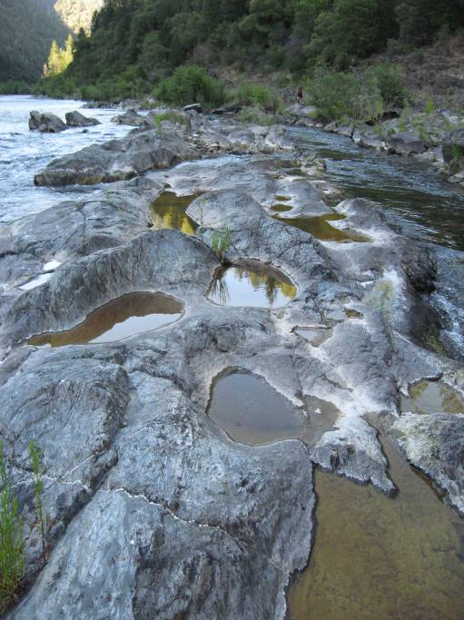
FB-E | FB-F
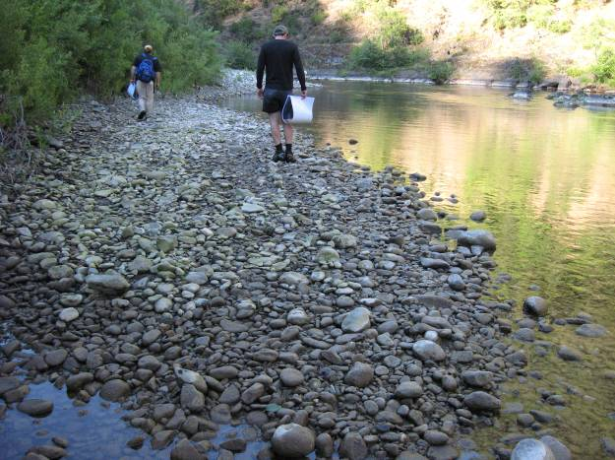 | 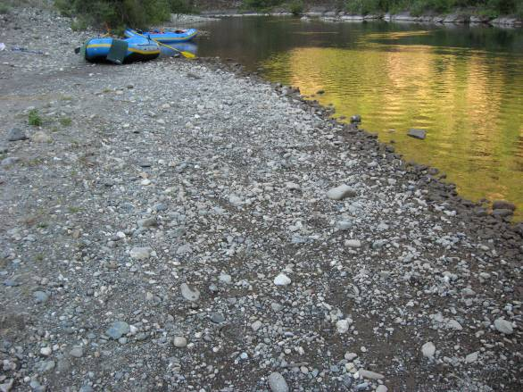

Potential Stranding/Trapping Areas Surveyed at Fords Bar.

FB-G | FB-H
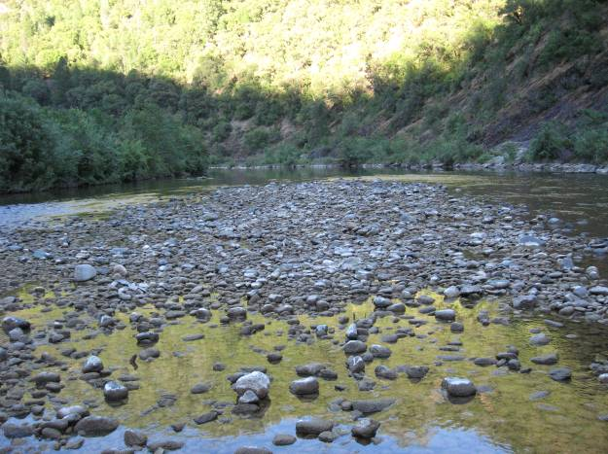 | 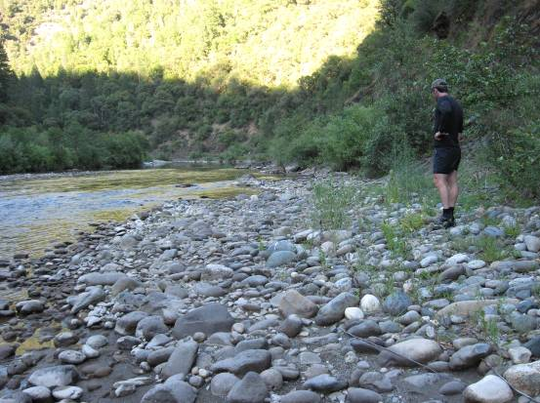
FB-I | FB-J
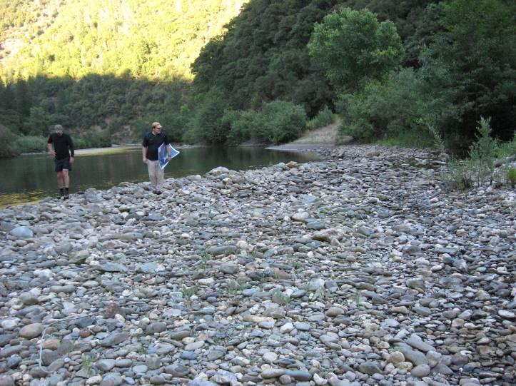 | 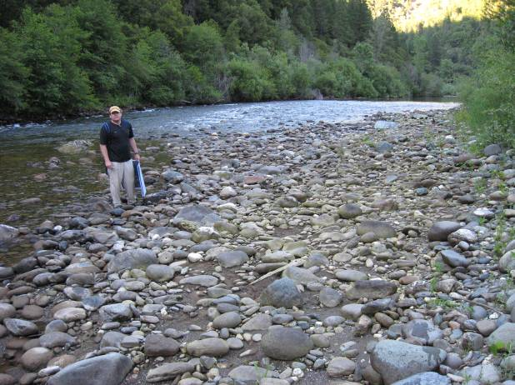

Potential Stranding/Trapping Areas Surveyed at Fords Bar.

FB-K | FB-L
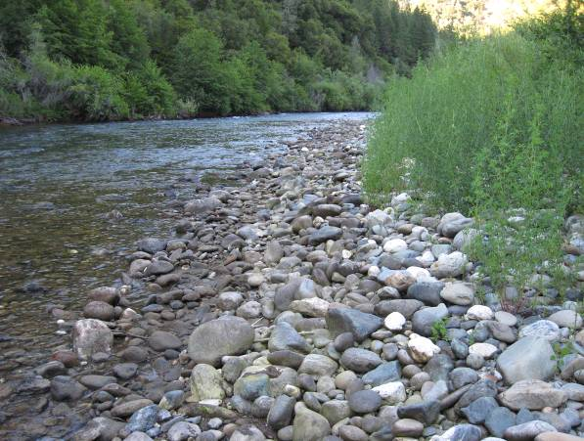 | 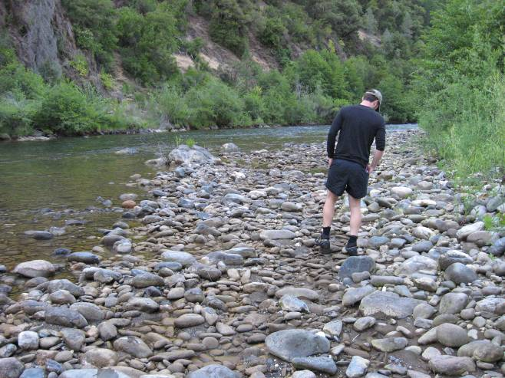
FB-M | FB-N
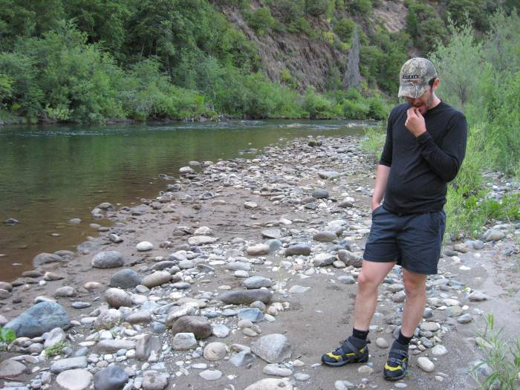 | 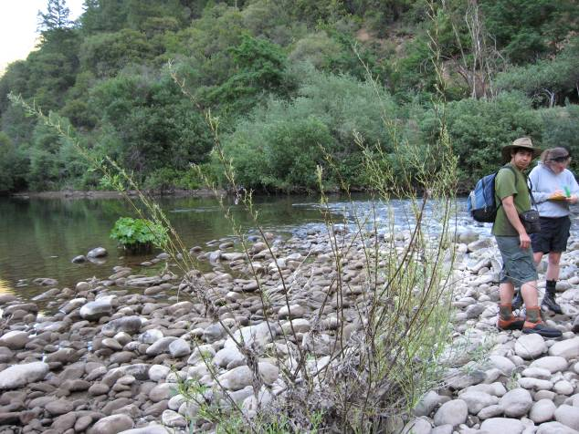

Potential Stranding/Trapping Areas Surveyed at Fords Bar.

FB-O | FB-P
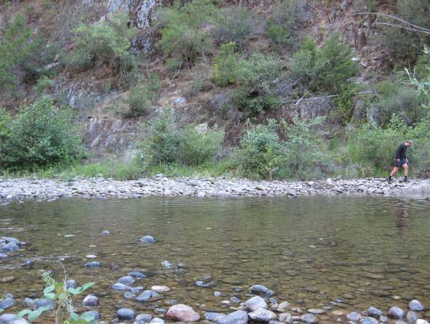 | 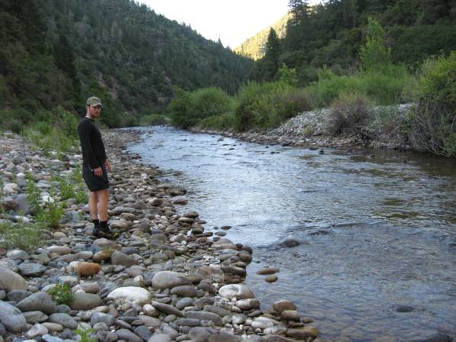
FB-Q | FB-R
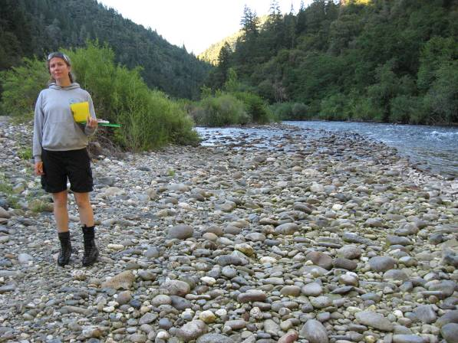 | 

